**GEOG5003 – Assignment 1 Test Cases**

GUI Front-end window:

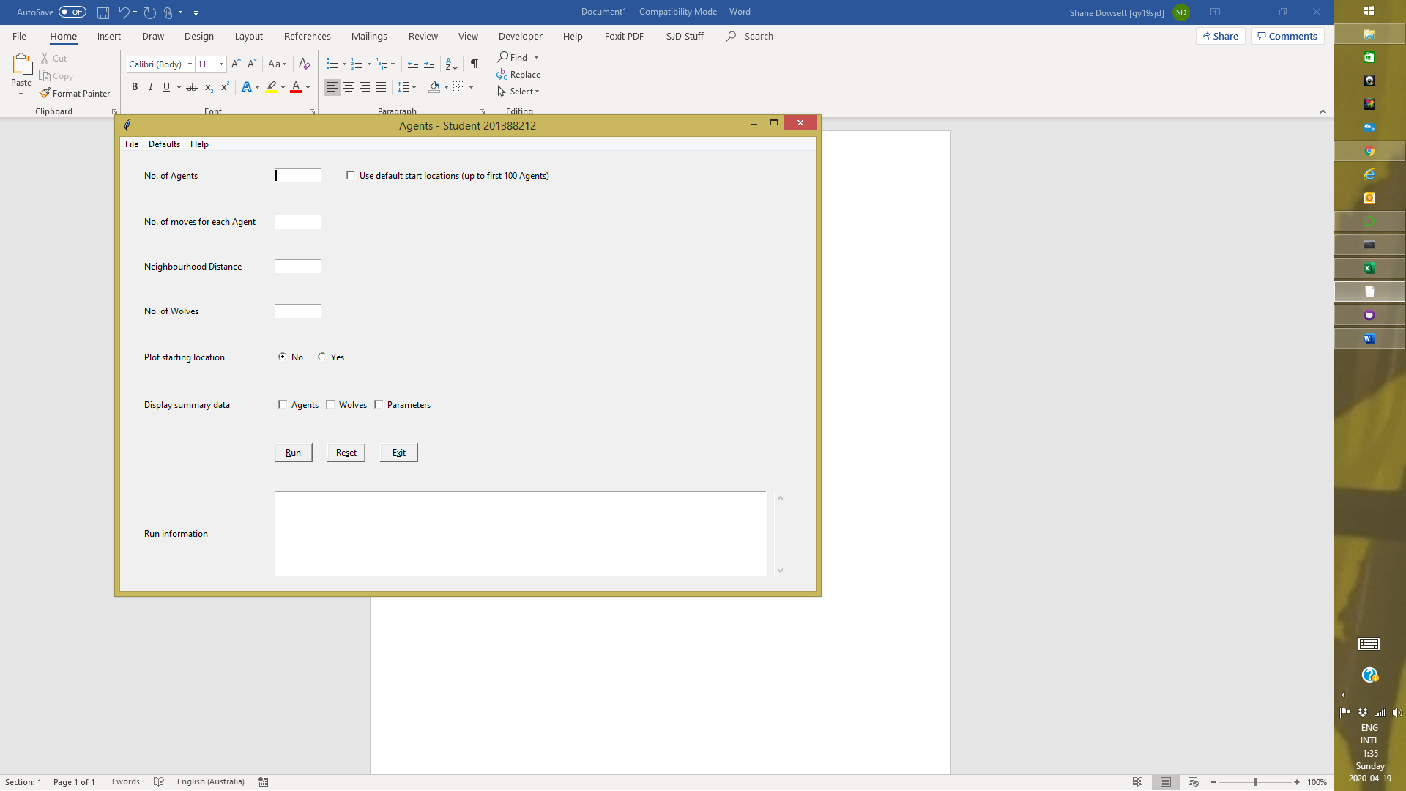

Code includes basic practical requirements plus the following optional task as suggested if time permits:

|  |  |  |  |  |  |
| --- | --- | --- | --- | --- | --- |
| **Practicals** | | **Description** | | **Included?** | |
| Agents | | **protect the**self.x**and**self.y**variables by renaming them**self._x**and**self._y**and implementing a**property**attribute for them** | | Yes | |
| I/O | | Write out the environment as a file at the end? | | Yes | |
|  | | Write out a second file with total amount stored by all the agents on a line?  Append the data rather than clearing it each time it runs? | | Yes | |
|  | | override __str__(self) in the agents | | Yes | |
|  | | Get the agents to wander around the full environment. | | Yes | |
|  | | Get Agents to eat the last few bits of environment, if there's less than 10 left, without leaving negative values? | | Yes | |
|  | | Get the agents to sick up their store in a location if they've been greedy guts and eaten more than 100 units. | | Yes | |
| Communicating | | Read from the command line | | Yes | |
|  | | Use subprocess functions | | Yes | |
| Animation / Behaviour | | Added a new type of agent (Wolf) | | Yes | |
|  | |  | |  | |
| **Test**  **#** | **Description** | | **Comments / Expected Results** | | **Pass /**  **Fail** |
| **1** | **Navigation** | |  | |  |
| 1.1 | Start app from command line running modelhome.py | | Loads GUI front end. | | Pass |
| 1.2 | Start app from command line running modelmain.py | | Runs app without GUI front-end. | | Pass |
| 1.3 | Exit app using Alt-x | | Program exits. | | Pass |
| 1.4 | Exit app using File > Exit | | Program exits. | | Pass |
| 1.5 | Exit app using Exit button | | Program exits. | | Pass |
| 1.6 | Help > Inputs | | Returns modelmain.py -h information.  Pop-up window appears. | | Pass |
| 1.7 | Help > About | | Pop-up window appears. | | Pass |
| 1.8 | Defaults > Create | | Disabled and greyed out (Added for demonstration purposes). | | Pass |
| 1.9 | Defaults > View | | Disabled and greyed out (Added for demonstration purposes). | | Pass |
| 1.10 | Reset fields using Alt-s | | All Entry fields cleared.  Plot starting location set to “No”.  All Check Buttons unchecked.  Run Information cleared. | | Pass |
| 1.11 | Reset fields using File > Reset | | All Entry fields cleared.  Plot starting location set to “No”.  All Check Buttons unchecked.  Run Information cleared. | | Pass |
| 1.12 | Reset fields using Reset button | | All Entry fields cleared.  Plot starting location set to “No”.  All Check Buttons unchecked.  Run Information cleared. | | Pass |
| 1.13 | Run app using Alt-r | | Matplotlib window appears (if no errors).  Error displayed in Run Information. | | Pass |
| 1.14 | Run app using File > Run | | Matplotlib window appears (if no errors).  Error displayed in Run Information. | | Pass |
| 1.15 | Run app using Run button | | Matplotlib window appears (if no errors).  Error displayed in Run Information. | | Pass |
|  |  | |  | |  |
| **2** | **Front-end fields (initial display)** | |  | |  |
| 2.1 | Entry Fields, Text box | | All empty. | | Pass |
| 2.2 | Radio Button set | | Set to “No” option. | | Pass |
| 2.3 | Check Buttons | | All unchecked. | | Pass |
| 2.4 | Cursor position | | Located in No. of Agents field. | | Pass |
|  |  | |  | |  |
| **3** | **Front-end field (after any run)** | |  | |  |
| 3.1 | Entry Fields, Radio Buttons, Check buttons | | All unchanged | | Pass |
| 3.2 | Text box | | Contains any relevant requested information depending on Display Summary Data Check buttons checked at the time.  Any error messages. | | Pass |
| 3.3 | Cursor position | | Located on Run Button. | | Pass |
|  |  | |  | |  |
| **4** | **Front-end fields – No. of Agents** | |  | |  |
| 4.1 | Empty | | No argument parsed.  Defaults to 10 (hard coded). | | Pass |
| 4.2 | Not empty | | Contents parsed into modelmain.py. | | Pass |
| 4.3 | Contains at least 1 Alphanumeric character | | Program terminates.  Error displayed in Run Information. | | Pass |
| 4.4 | Contains as least 1 space character | | Program terminates.  Error displayed in Run Information. | | Pass |
| 4.5 | Contains zero | | Program terminates.  Error displayed in Run Information. | | Pass |
| 4.6 | Contains a negative integer | | Program terminates.  Error displayed in Run Information. | | Pass |
| 4.7 | Contains a floating-point number | | Program terminates.  Error displayed in Run Information. | | Pass |
| 4.8 | Contains a positive integer | | Program overrides default.  Matplotlib window contains corresponding number of Agent plots. | | Pass |
|  |  | |  | |  |
| **5** | **Front-end fields – Use default start locations** | |  | |  |
| 5.1 | Unchecked | | All agents have randomised starting locations within supplied raster boundaries. | | Pass |
| 5.2 | Checked | | First 100 agents starting locations clustered in area bounded by 0,0 and 99,99  Remaining agents starting locations randomised within supplied raster boundaries. | | Pass |
|  | *Additional notes* | | *For either option:*  *Matplotlib window contains corresponding plots if “Plot starting location” = Yes.*  *Run Information contains corresponding x y coordinates if “Display summary data – Agent” is checked.* | |  |
|  |  | |  | |  |
| **6** | **Front-end fields – No. of moves for each Agent** | |  | |  |
| 6.1 | Empty | | No argument parsed  Defaults to 100 (hard coded) | | Pass |
| 6.2 | Not empty | | Contents parsed into modelmain.py. | | Pass |
| 6.3 | Contains at least 1 Alphanumeric character | | Program terminates.  Error displayed in Run Information. | | Pass |
| 6.4 | Contains as least 1 space character | | Program terminates.  Error displayed in Run Information. | | Pass |
| 6.5 | Contains zero | | Program terminates.  Error displayed in Run Information. | | Pass |
| 6.6 | Contains a negative integer | | Program terminates.  Error displayed in Run Information. | | Pass |
| 6.7 | Contains a floating-point number | | Program terminates.  Error displayed in Run Information. | | Pass |
| 6.8 | Contains a positive integer | | Program overrides default.  Matplotlib window contains:  Agent finishing location plots differ to starting location plots if “Plot starting location” = Yes.  Environment appears to have been “nibbled” away. | | Pass |
|  |  | |  | |  |
| **7** | **Front-end fields – Neighbourhood Distance** | |  | |  |
| 7.1 | Empty | | No argument parsed  Defaults to 20 (hard coded) | | Pass |
| 7.2 | Not empty | | Contents parsed into modelmain.py. | | Pass |
| 7.3 | Contains at least 1 Alphanumeric character | | Program terminates.  Error displayed in Run Information. | | Pass |
| 7.4 | Contains as least 1 space character | | Program terminates.  Error displayed in Run Information. | | Pass |
| 7.5 | Contains zero | | Program terminates.  Error displayed in Run Information. | | Pass |
| 7.6 | Contains a negative integer | | Program terminates.  Error displayed in Run Information. | | Pass |
| 7.7 | Contains a floating-point number | | Program terminates.  Error displayed in Run Information. | | Pass |
| 7.8 | Contains a positive integer | | Program overrides default.  Contents of out2.txt contains some float data. | | Pass |
|  |  | |  | |  |
| **8** | **Front-end fields – No. of Wolves** | |  | |  |
| 8.1 | Empty | | No argument parsed  Defaults to 5 (hard coded) | | Pass |
| 8.2 | Not empty | | Contents parsed into modelmain.py. | | Pass |
| 8.3 | Contains at least 1 Alphanumeric character | | Program terminates.  Error displayed in Run Information. | | Pass |
| 8.4 | Contains as least 1 space character | | Program terminates.  Error displayed in Run Information. | | Pass |
| 8.5 | Contains zero | | Program terminates.  Error displayed in Run Information. | | Pass |
| 8.6 | Contains a negative integer | | Program terminates.  Error displayed in Run Information. | | Pass |
| 8.7 | Contains a floating-point number | | Program terminates.  Error displayed in Run Information. | | Pass |
| 8.8 | Contains a positive integer | | Program overrides default.  Matplotlib window contains single Wolf starting location plot if “Plot starting location” = Yes.  Matplotlib window contains corresponding number of finishing location Wolf plots. | | Pass |
|  |  | |  | |  |
| **9** | **Front-end fields – Plot starting locations** | |  | |  |
| 9.1 | No | | Agent starting locations not plotted.  Wolf Pack starting location not plotted. | | Pass |
| 9.2 | Yes | | Program overrides default.  All agents starting locations plotted.  Single plot point for Wolf Pack. | | Pass |
| 9.3 | Mutually exclusive | | Yes | | Pass |
|  |  | |  | |  |
| **10** | **Front-end fields – Display Summary Data (Agents)** | |  | |  |
| 10.1 | Unchecked | | Program overrides default.  No Agent information returned.  No effect on plotting. | | Pass |
| 10.2 | Checked | | Program overrides default.  Initial Agent information returned and displayed in Run Information text box.  Final Agent information returned and displayed in Run Information text box. | | Pass |
|  |  | |  | |  |
| **11** | **Front-end fields – Display Summary Data (Wolves)** | |  | |  |
| 11.1 | Unchecked | | Program overrides default.  No Wolf information returned.  No effect on plotting. | | Pass |
| 11.2 | Checked | | Program overrides default.  Initial Wolf information returned and displayed in Run Information text box.  Final Wolf information returned and displayed in Run Information text box. | | Pass |
|  |  | |  | |  |
| **12** | **Front-end fields – Display Summary Data (Parameters)** | |  | |  |
| 12.1 | Unchecked | | No parameter information returned. | | Pass |
| 12.2 | Checked | | Program overrides default.  Summary of run parameters passed. | | Pass |
|  |  | |  | |  |
| **13** | **Input raster file (in.txt)** | |  | |  |
| 13.1 | No. of cell values in each row not consistent | | Program terminates.  Error displayed in Run Information. | | Pass |
| 13.2 | Cell value not numeric | | Program terminates.  Error displayed in Run Information. | | Pass |
|  |  | |  | |  |
| **14** | **General running of model without errors** | |  | |  |
| 14.1 | Single Agent – not killed | | Agent continues to move for full number specified times.  Final “store” value is an integer.  Final “moves” value = Input value.  Final “alive” value = Y. | | Pass |
| 14.2 | Single Agent - killed | | Agent prematurely stops moving.  Final “store” value is an integer.  Final “moves” value < input value.  Final “alive” value = N.  Final x y coordinates match one of the wolves x y coordinates.  Finishing location plot will be hidden by finishing location of the wolf who made the kill. | | Pass |
| 14.3 | Multiple Agents – all not killed | | For each Agent:  Continues to move for full number specified times.  Final “store” value is an integer or a float number.  Final “moves” value = Input value.  Final “alive” value = Y. | | Pass |
| 14.4 | Multiple Agents – some killed | | For each Agent not killed:  Continues to move for full number specified times.  Final “store” value is an integer or a float number.  Final “moves” value = Input value.  Final “alive” value = Y .  For each Agent killed:  prematurely stops moving while alive .agents continue to move.  Final “store” value is an integer or a float number.  Final “moves” value < Input value.  Final “alive” value = N . | | Pass |
| 14.5 | Multiple Agents – all killed (not at same time) | | For each Agent:  Final “store” value is an integer or a float number.  Final “moves” value < Input value unless final kill occurred during the last set of moves.  Final “alive” value = N .  One of the Agent’s final x y coordinates match one of the wolves x y coordinates.  One of the Agent’s finishing location plot will be hidden by the finishing location of the wolf who made the final kill. | | Pass |
| 14.6 | Single Wolf – no kills | | Wolf continues to move for full number specified times.  Final “kills” value = 0. | | Pass |
| 14.7 | Single Wolf – some Agent kills | | Wolf continues to move for full number specified times.  Final “kills” value > 0. | | Pass |
| 14.8 | Single Wolf – all Agents killed | | Wolf prematurely stops moving upon final Agent kill.  Final “kills” value = no. of agents.  Final x y coordinates match one of the Agents x y coordinates.  Finishing location plot will hide finishing location of the last Agent killed. | | Pass |
| 14.9 | Multiple Wolves – no kills | | For each Wolf:  Continues to move for full number specified times.  Final “kills” value = 0. | | Pass |
| 14.10 | Multiple Wolves – some Agent kills | | For each Wolf:  Wolf continues to move for full number specified times.  Final “kills” value >= 0. | | Pass |
| 14.11 | Multiple Wolves – all Agents killed | | For each Wolf:  Prematurely stops moving upon final Agent kill by one of the Wolf Pack.  Final “kills” value >= 0.  Final x y coordinates match one of the Agents x y coordinates.  Finishing location plot will hide finishing location of the last Agent killed.  For Wolf Pack:  Sum of final “kills” values = no. of agents. | | Pass |
|  |  | |  | |  |
| **15** | **Stress Test** | |  | |  |
| 15.1 | Large number of Agent & Wolf movements | |  | |  |
|  |  | |  | |  |
| **16** | **Output files** | |  | |  |
| 16.1 | out1.txt (Environment data) | | Format and layout matches input file.  File overwritten for each run.  Contains same number of rows and cell as in.txt.  Each cell is in integer format.  Some cell values differ from corresponding cell from input file. | | Pass |
| 16.2 | out2.txt (Agent store data) | | File append to for each run.  One row per run.  One comma separated value for each Agent.  Each value is in float format to 2 decimal places unless it is a whole number. | | Pass |
| 16.3 | out3.txt (Wolf kill data) | | File append to for each run.  One row per run.  One comma separated value for each Wolf.  Each value is in integer format. | | Pass |

**GEOG5003 – Assignment 1 Testing Evidence**

**Test Case 1.6**

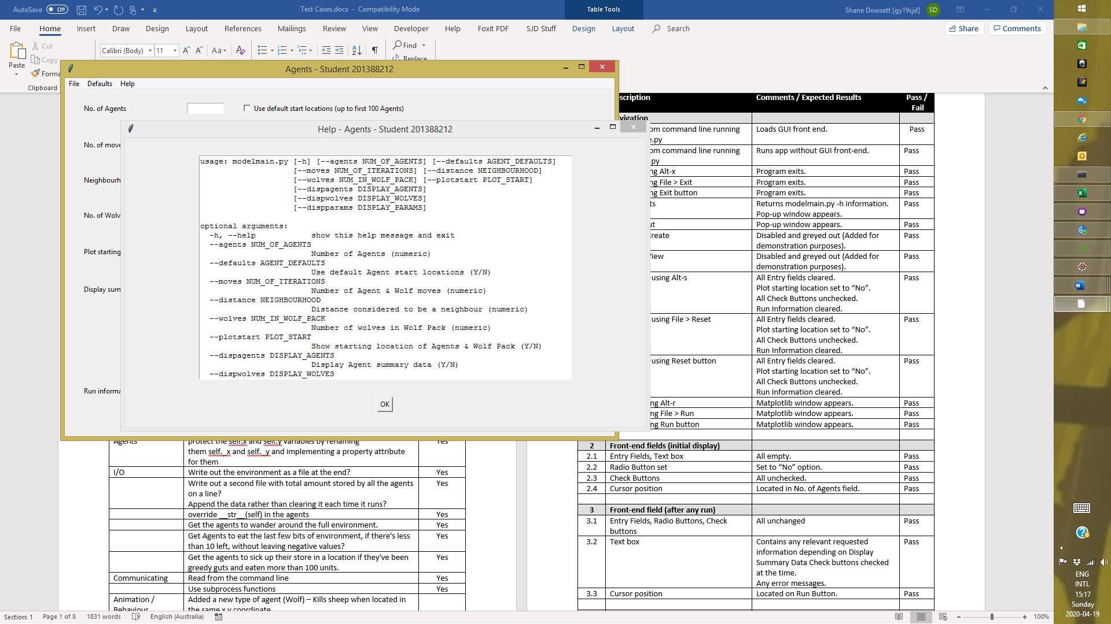

**Test Case 1.7**

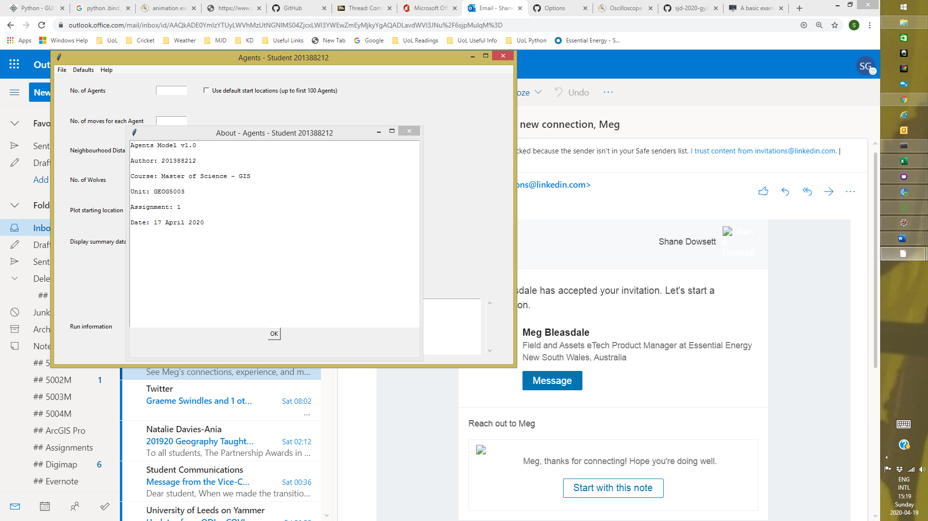

**Test Case 13.1**

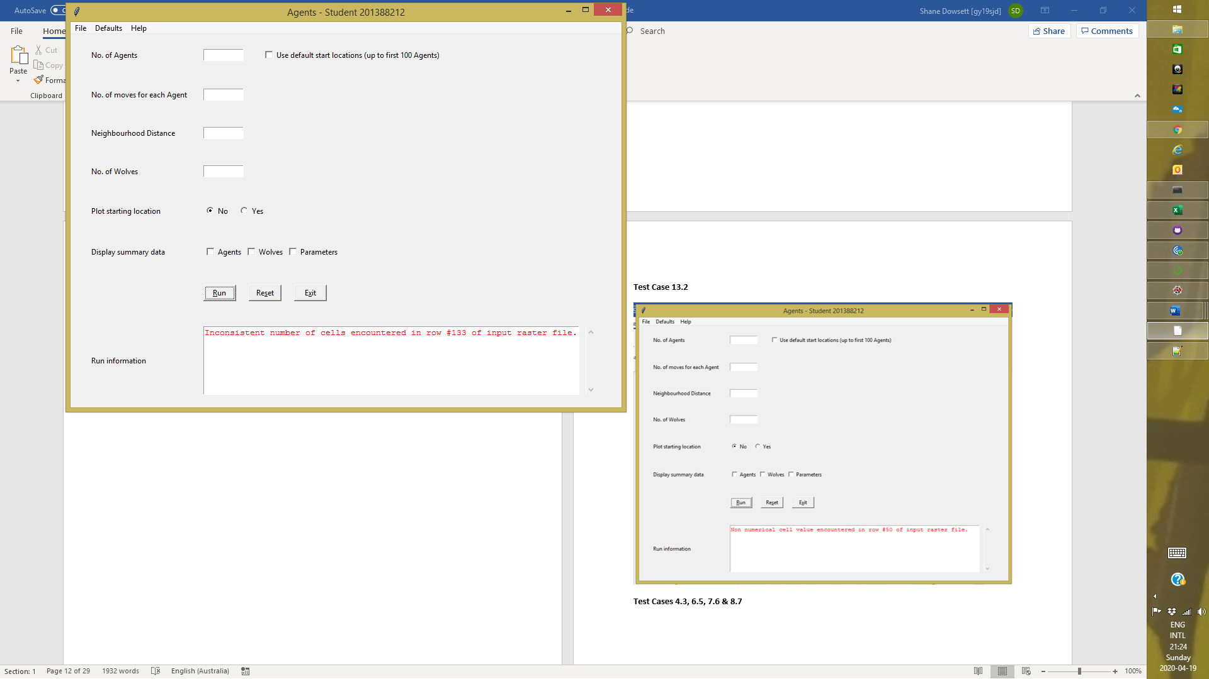

**Test Case 13.2**

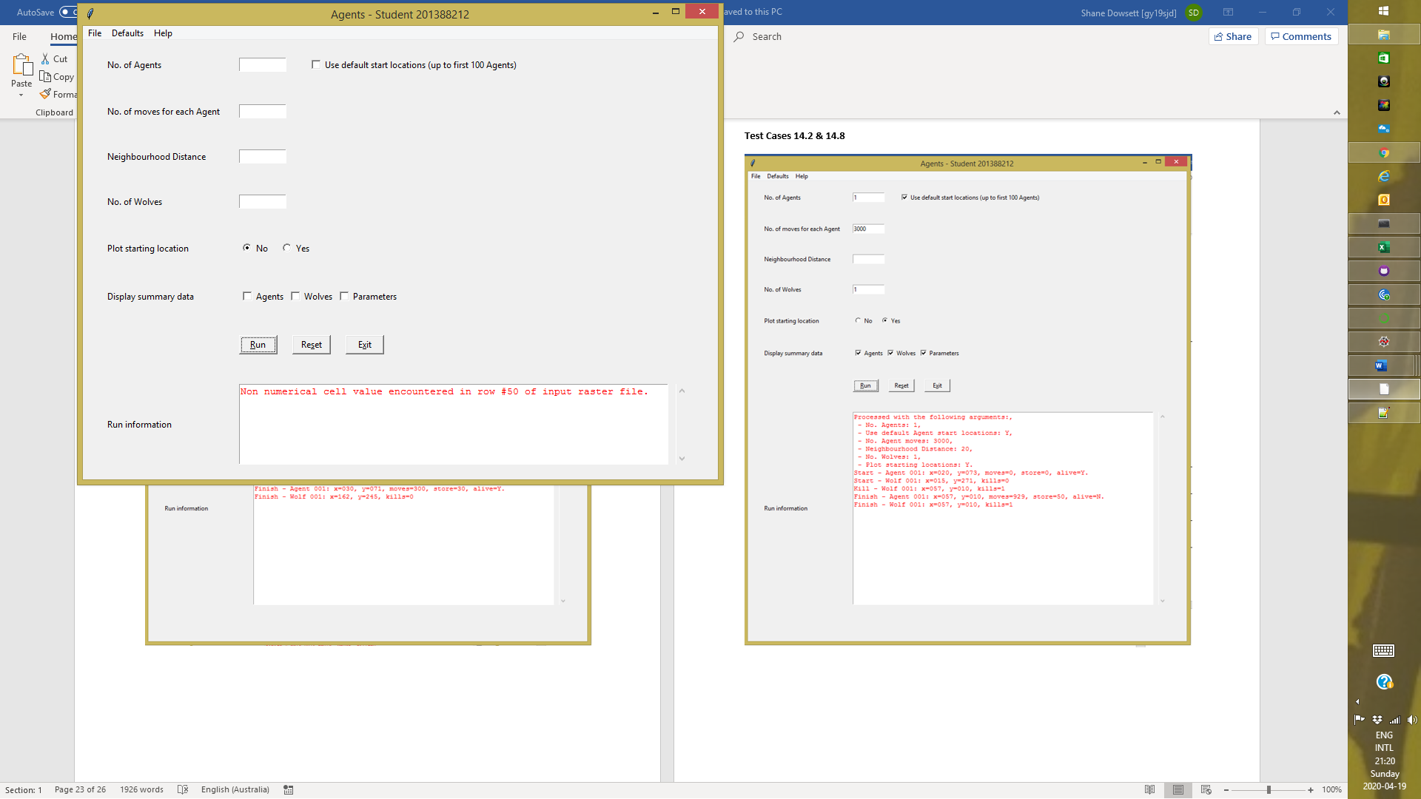

**Test Cases 4.3, 6.5, 7.6 & 8.7**

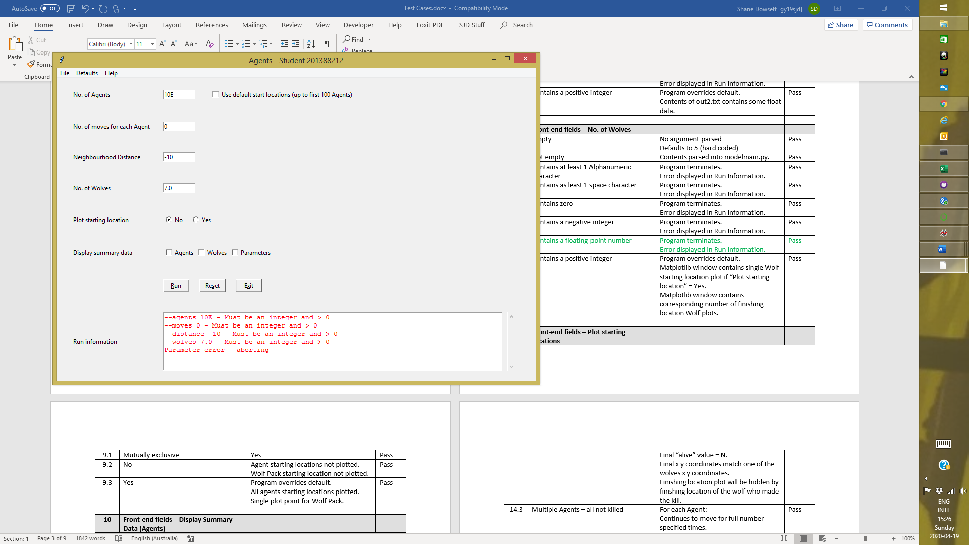

**Test Cases 4.1, 5.1, 6.1, 7.1, 8.1, 9.1, 10.1, 11.1 & 12.1**

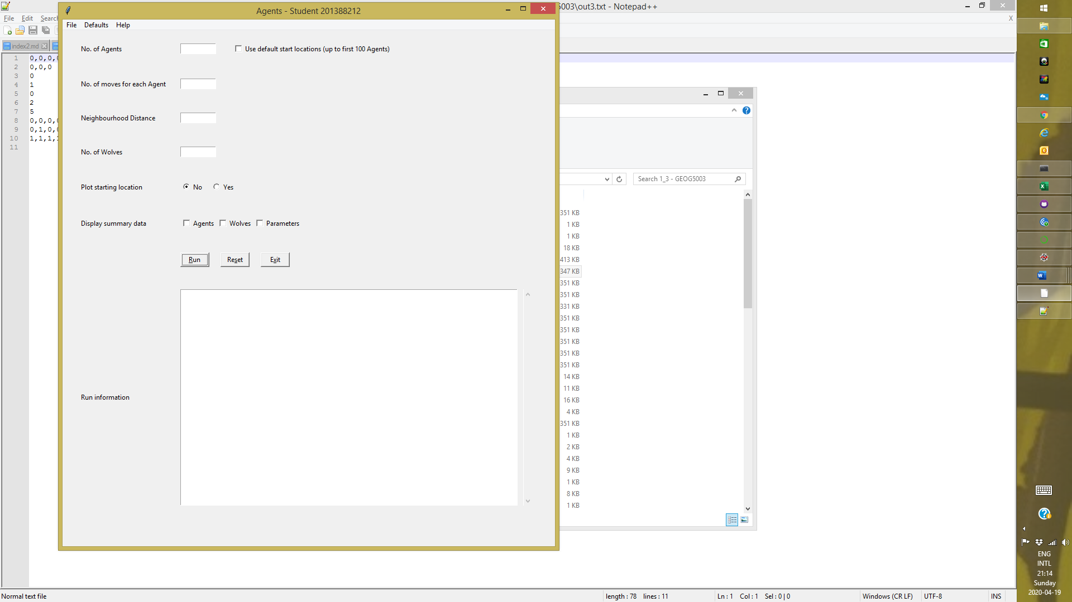

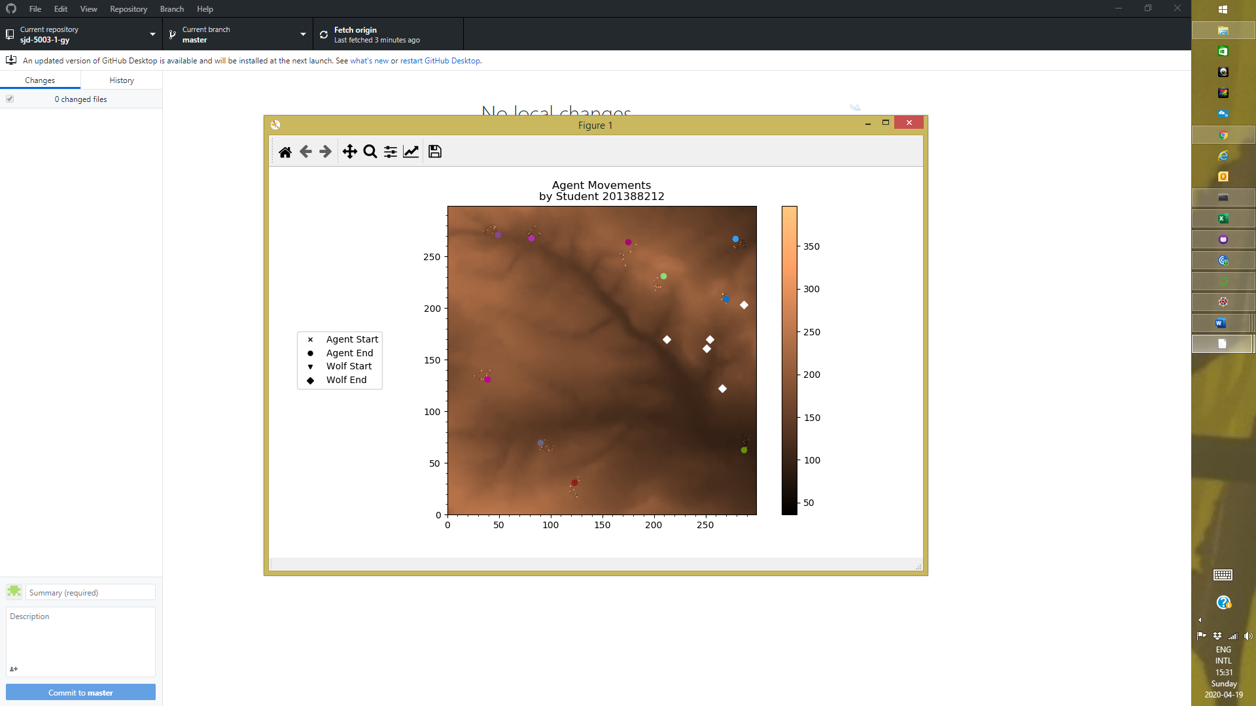

**Test Cases 4.2, 4.8, 5.2, 6.2, 6.8, 7.2, 7.8, 8.2, 8.8, 9.2, 10.2, 11.2 & 12.2**

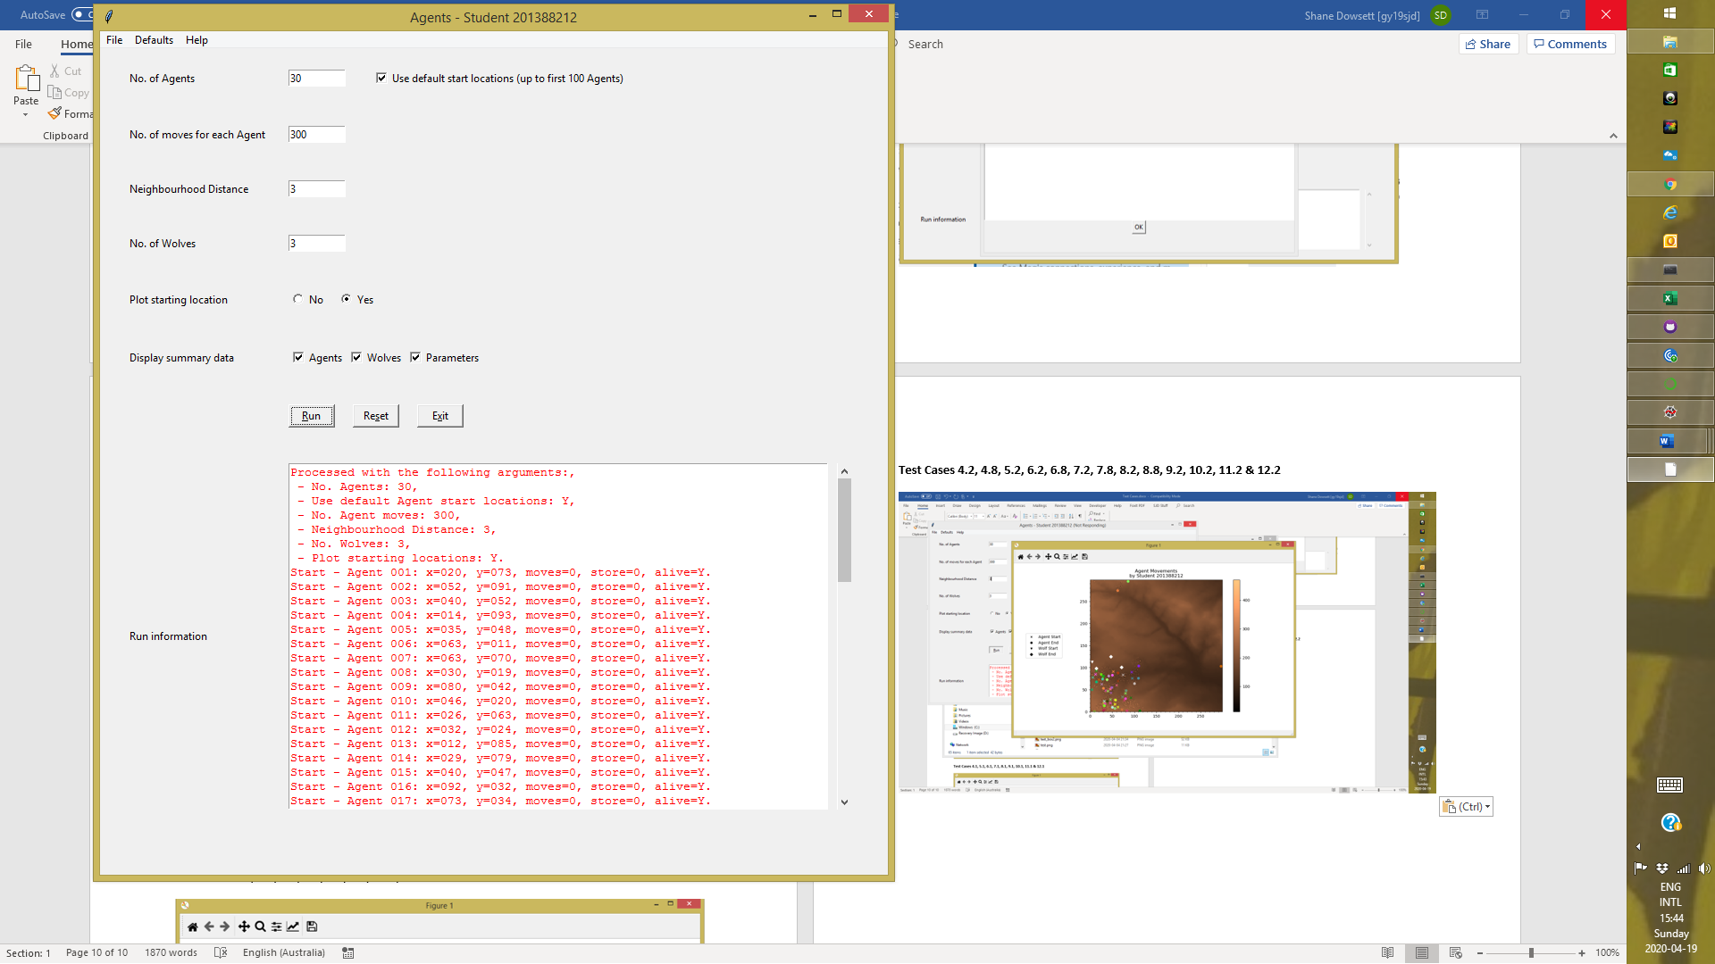

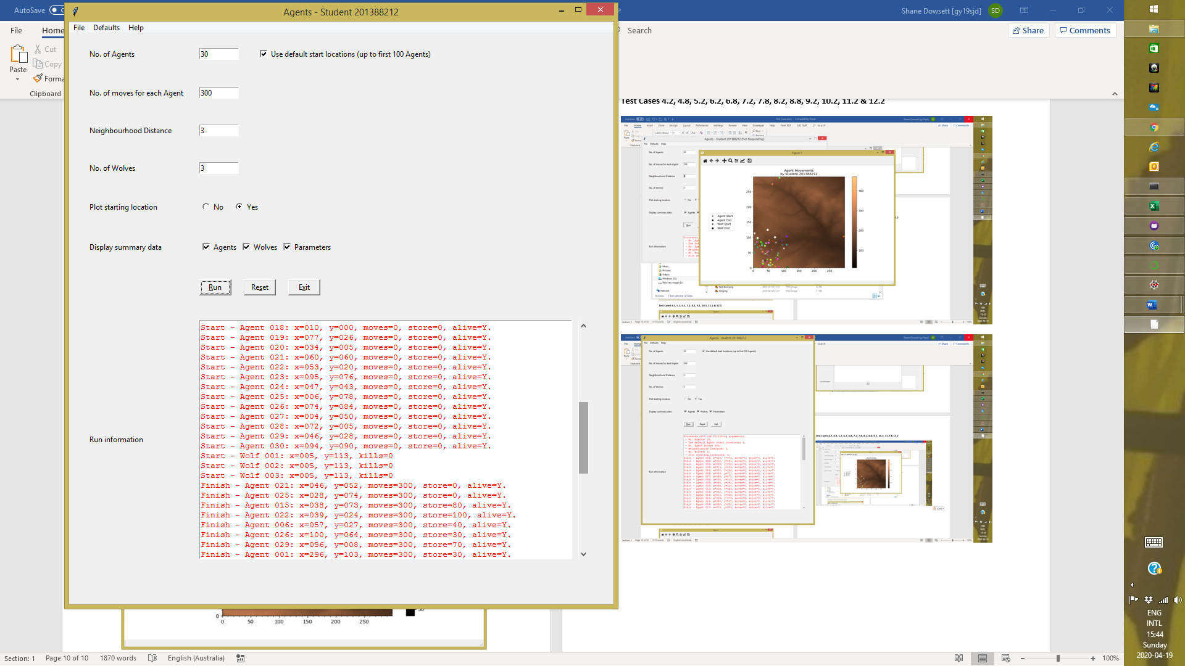

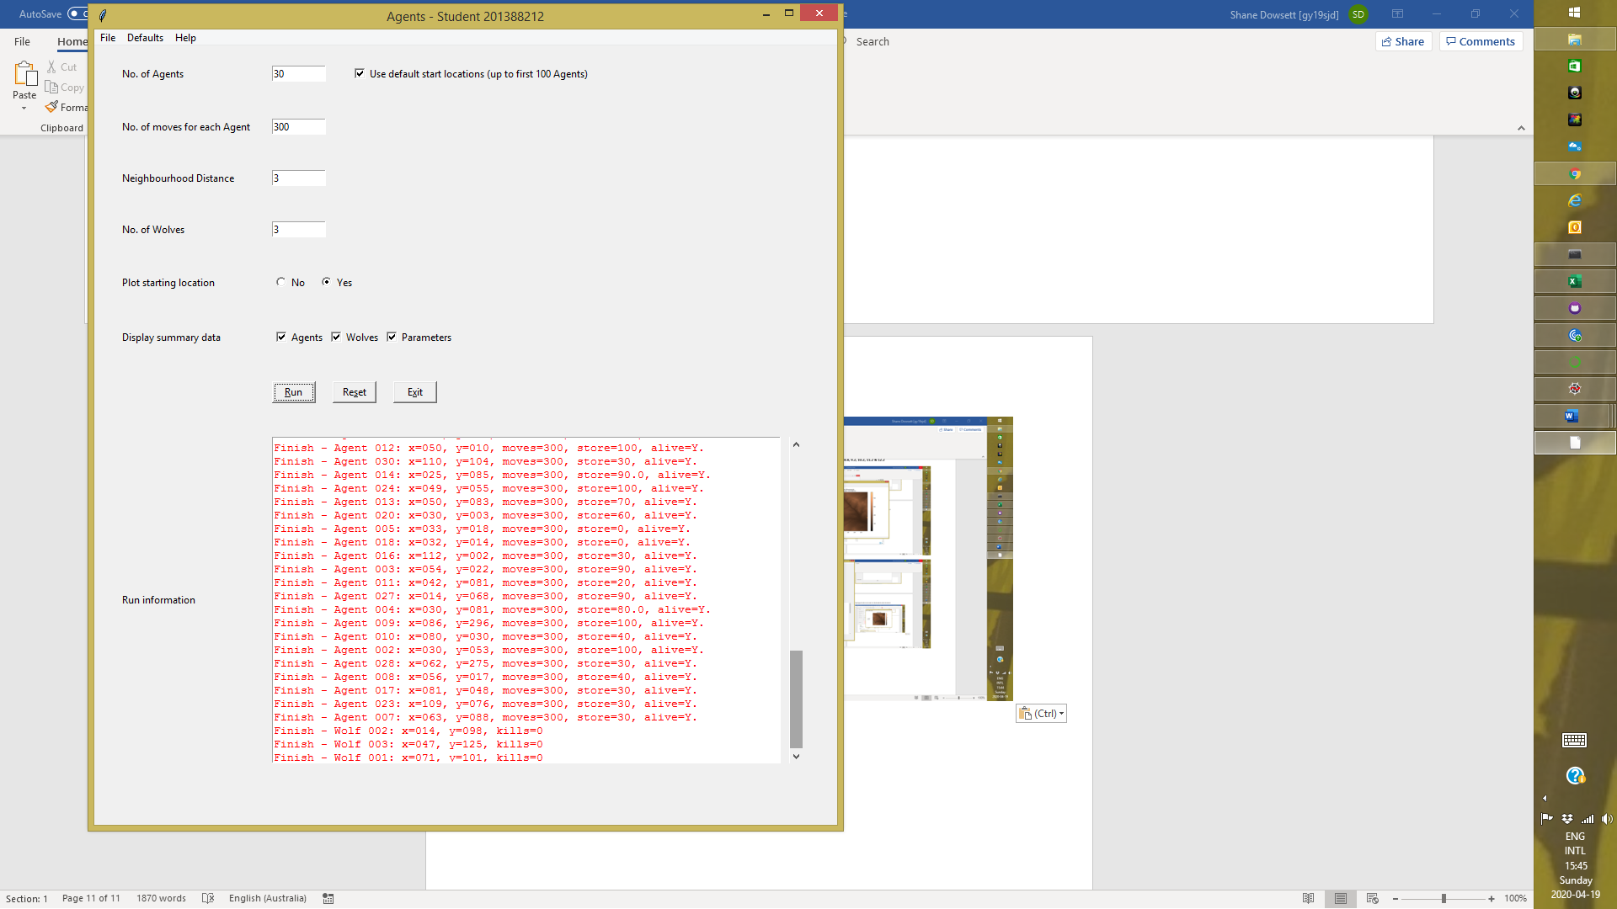

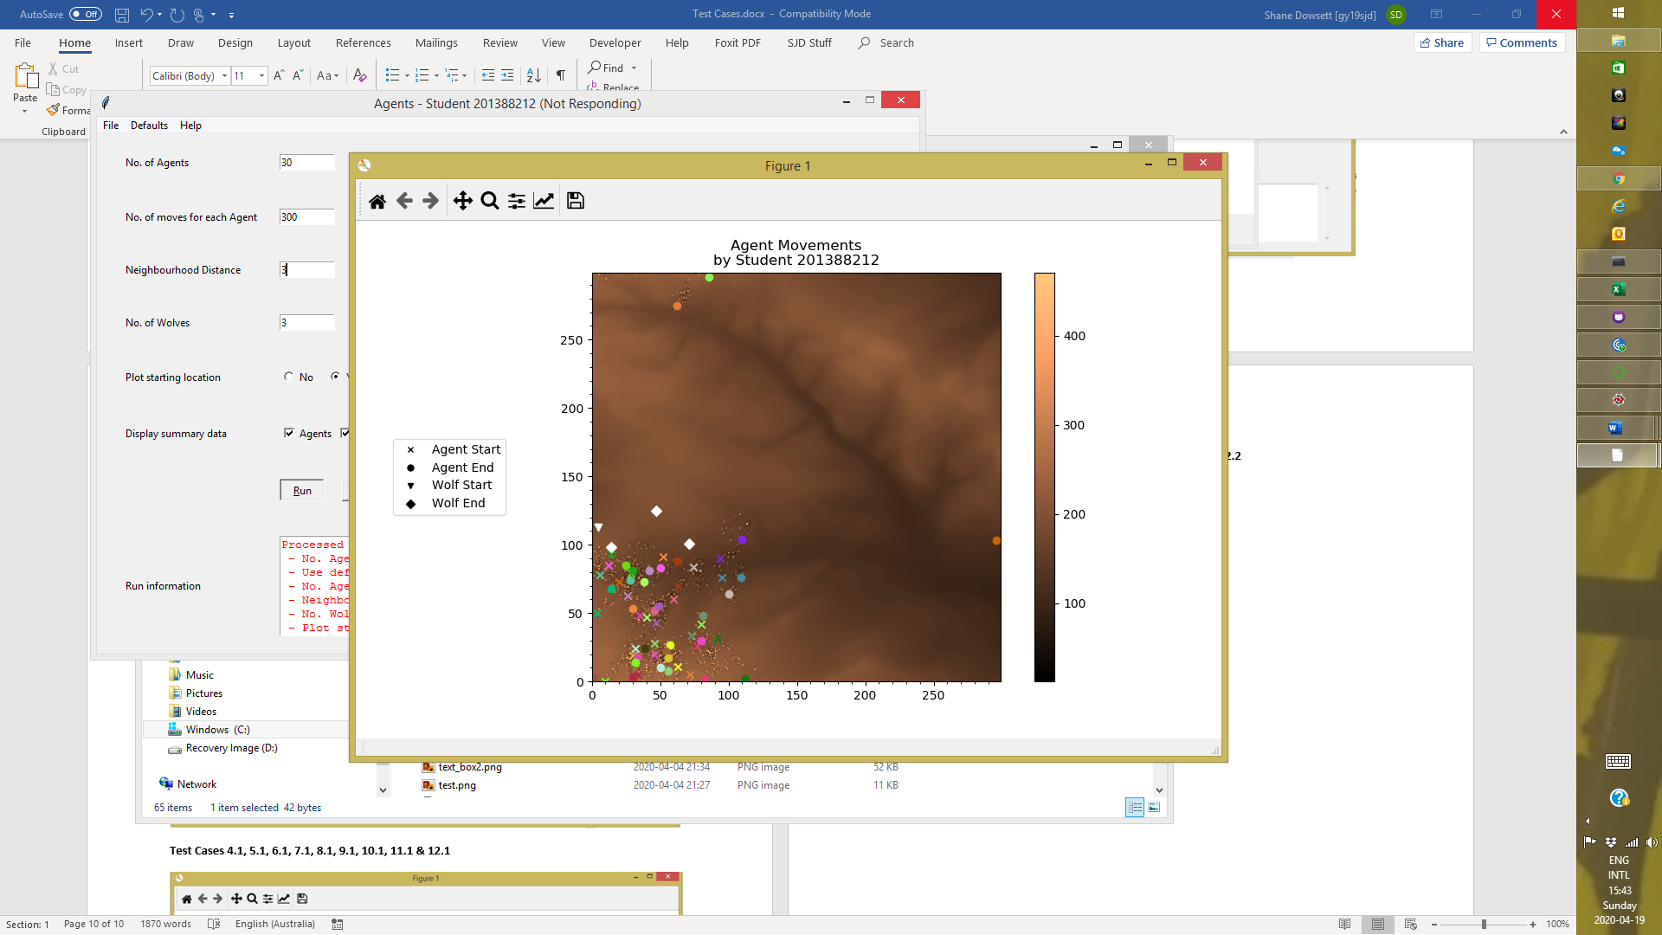

**Test Cases 14.1 & 14.6**

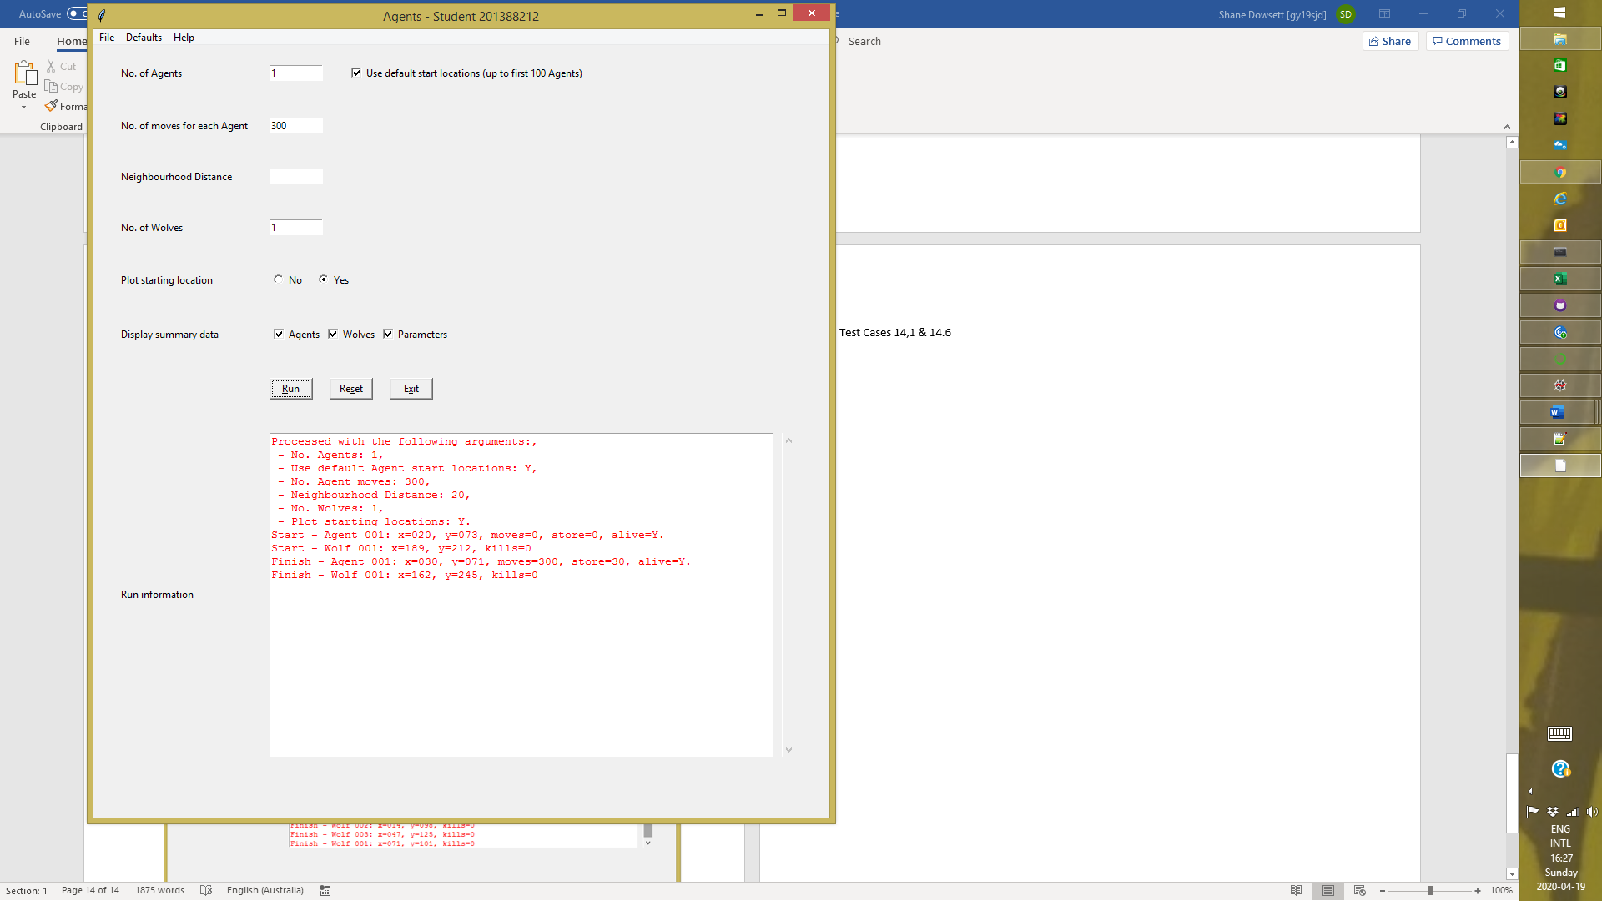

**Test Cases 14.2 & 14.8**

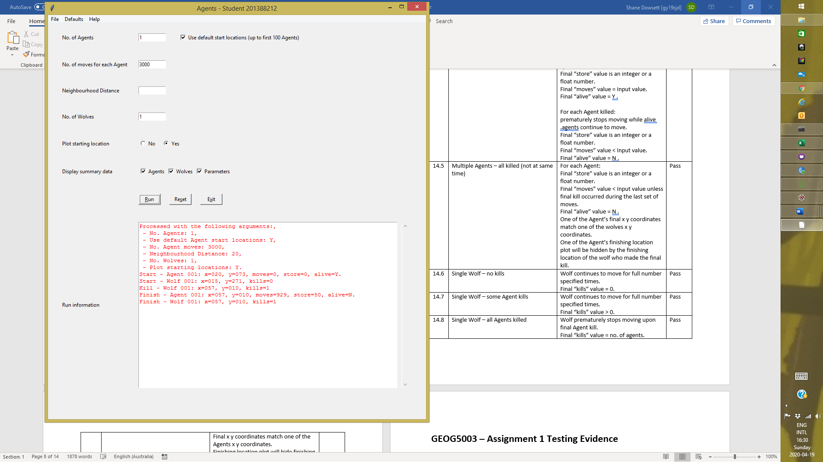

**Test Cases 14.3 & 14.7**

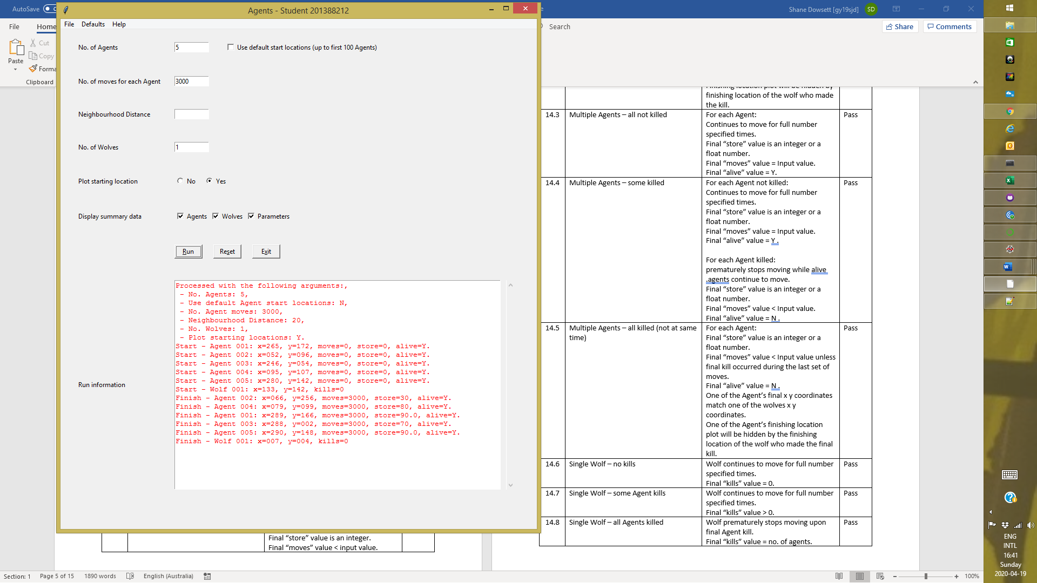

**Test Cases 14.4 & 14.7**

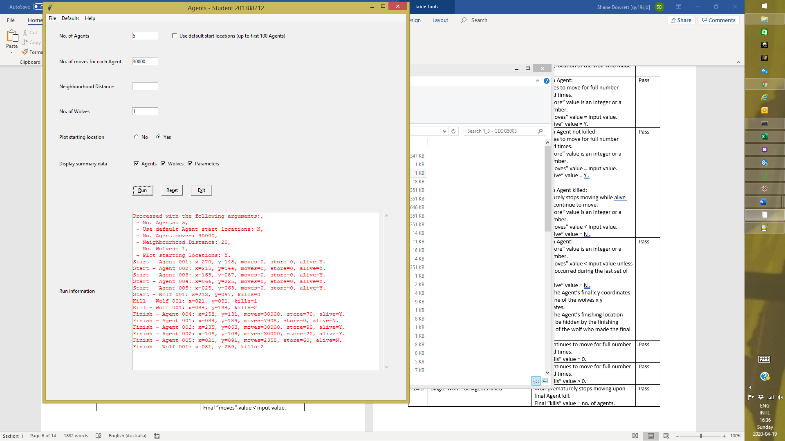

**Test Case 14.5**

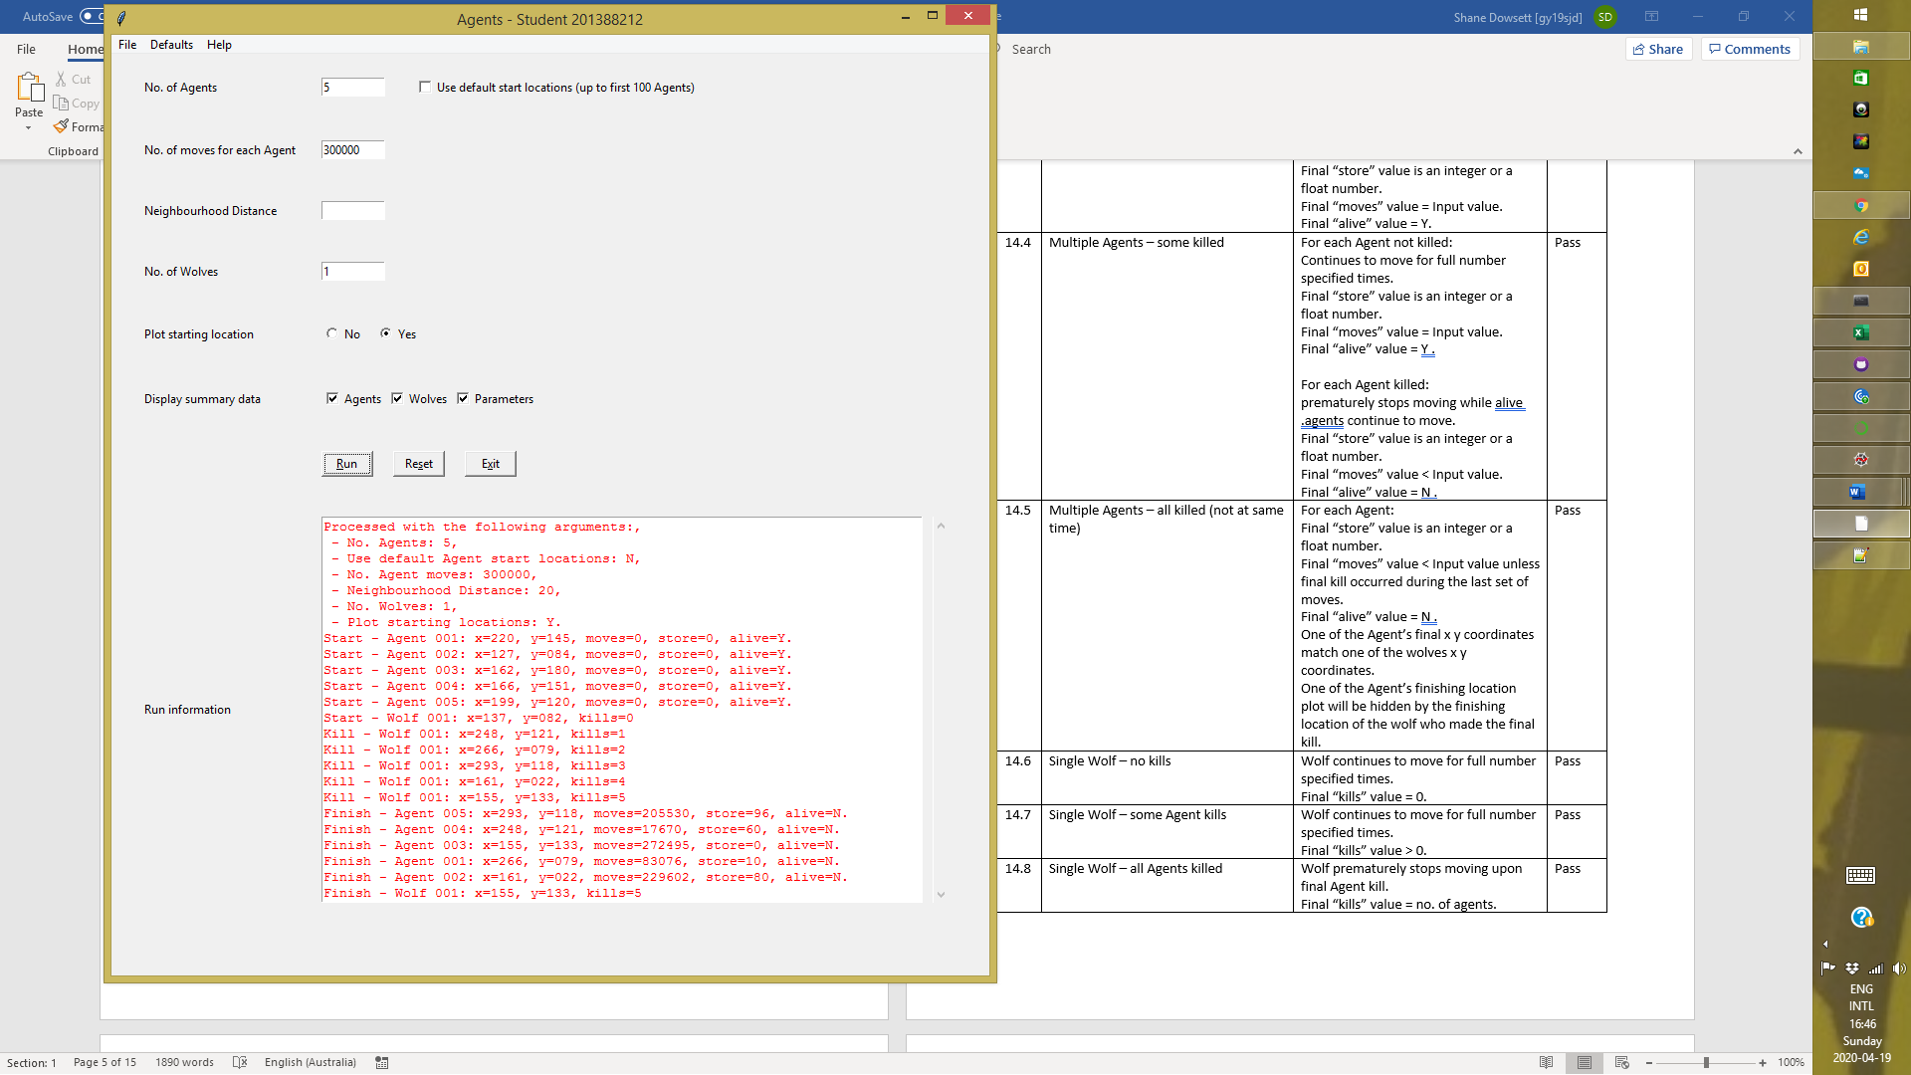

**Test Case 14.9**

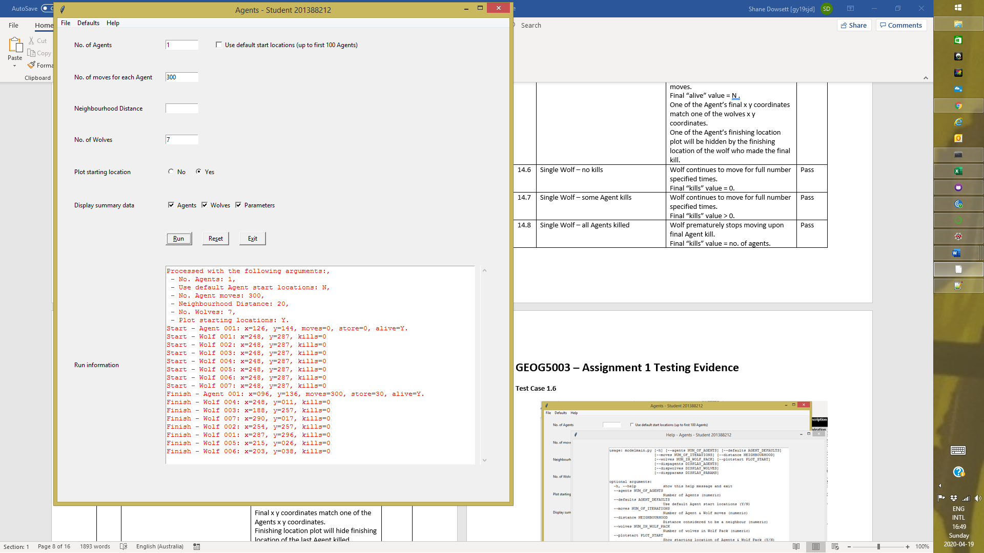

**Test Case 14.10**

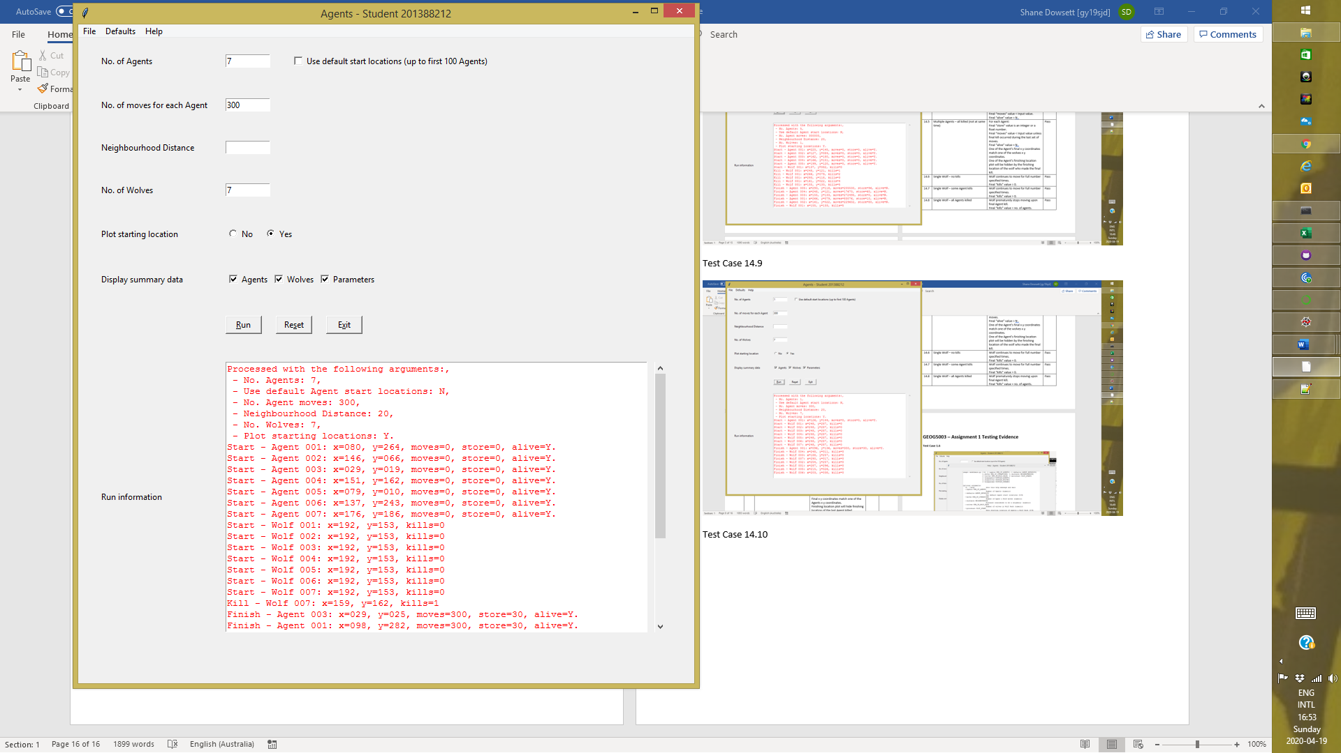

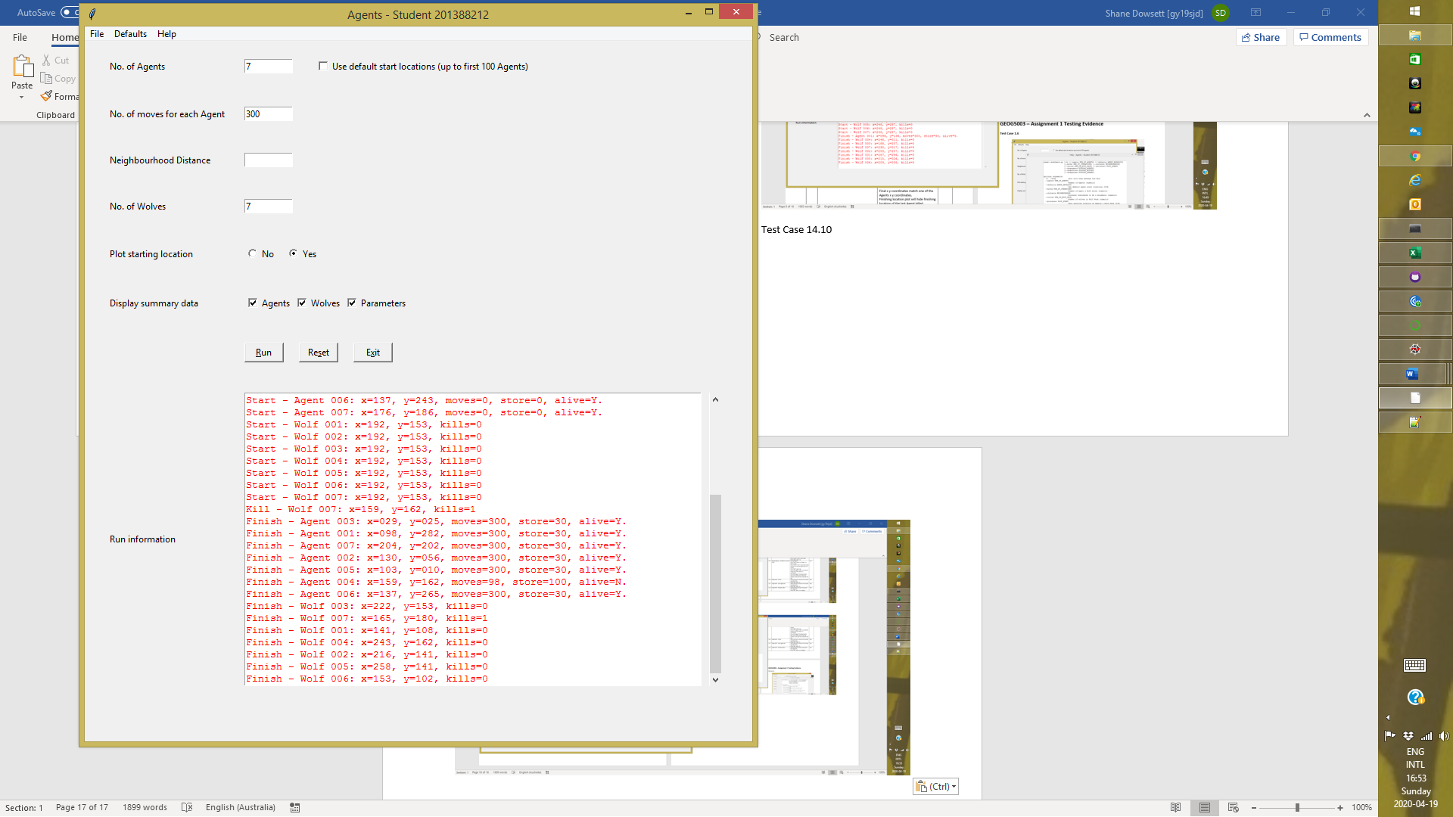

**Test Case 14.11**

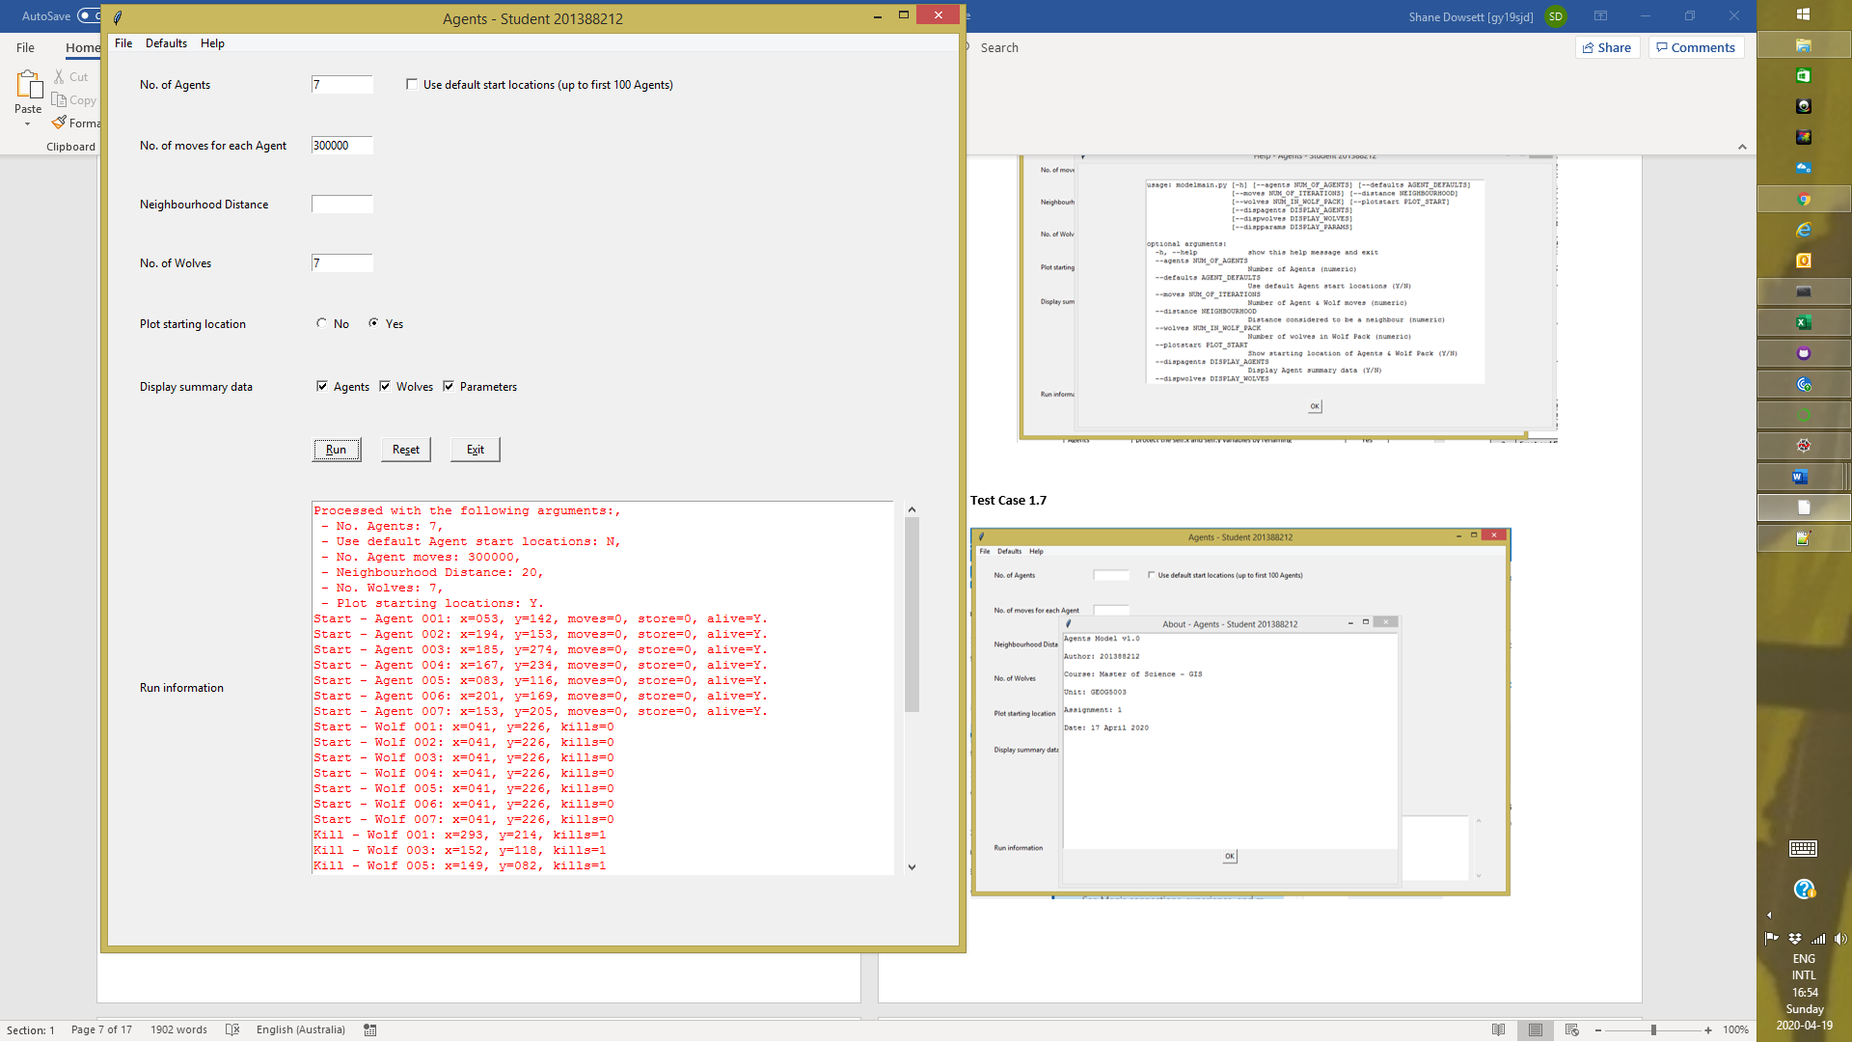

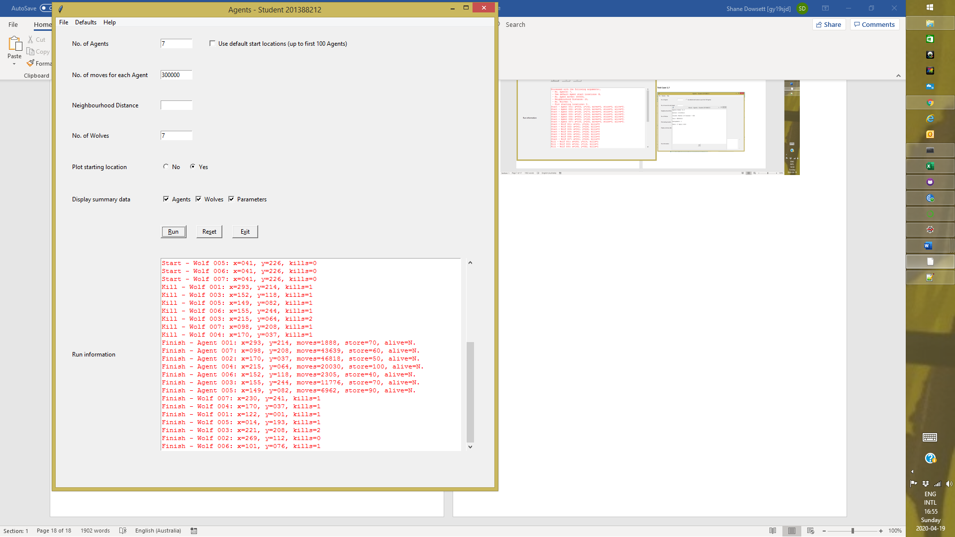

**Test 15.1, 16.1, 16.2 & 16.3**

